1. Open the image by using **ImageJ with Olympus Plugin**

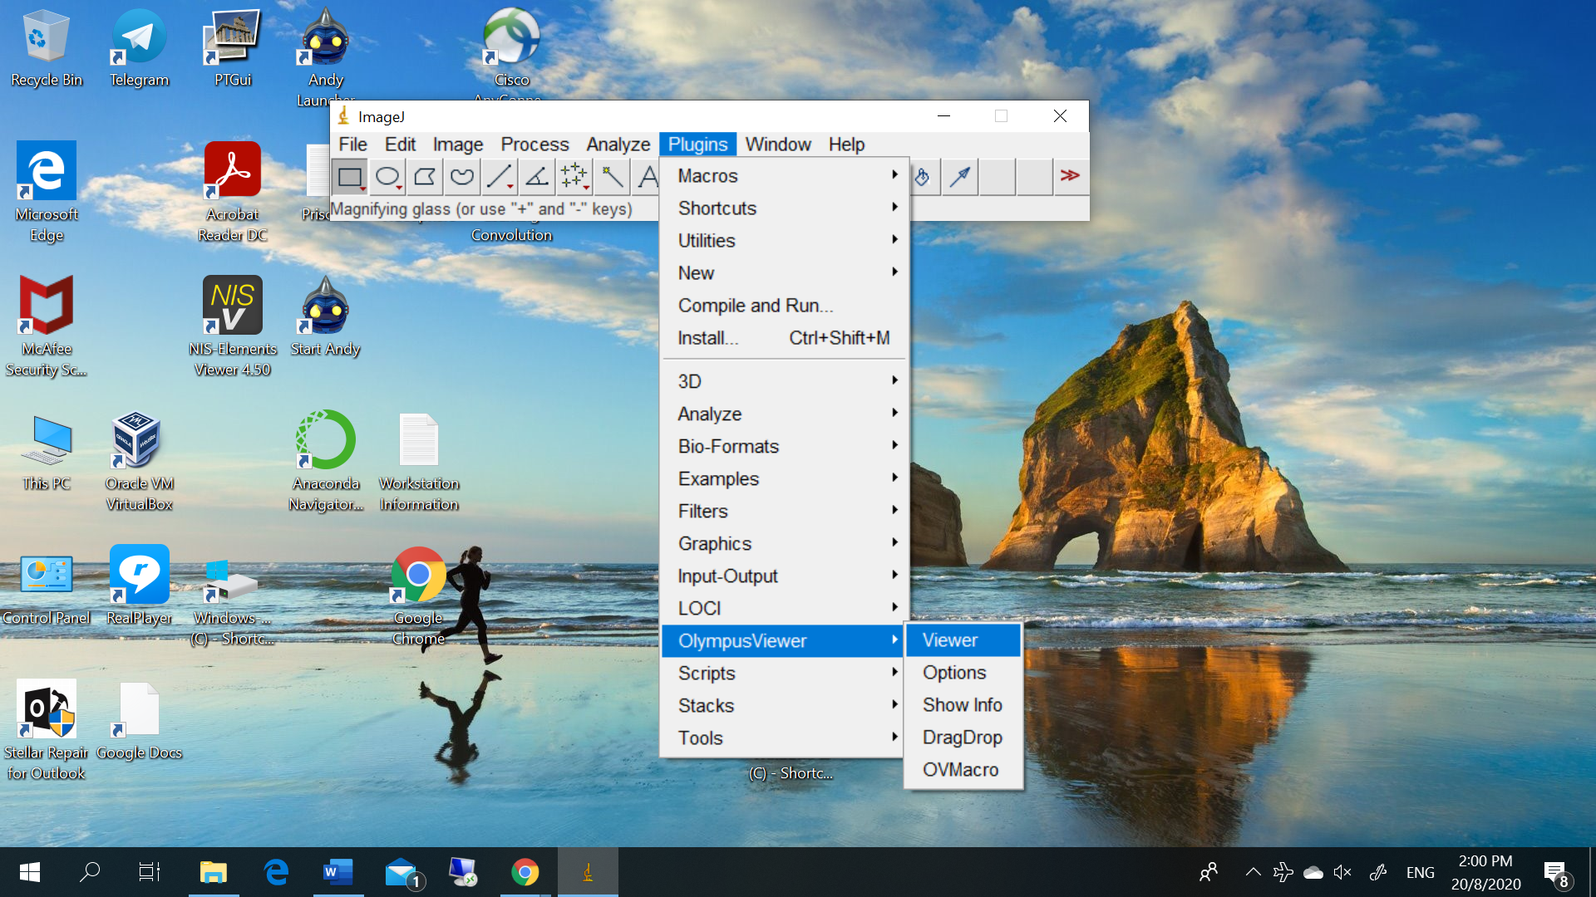

1. Choose the suitable image for viewing

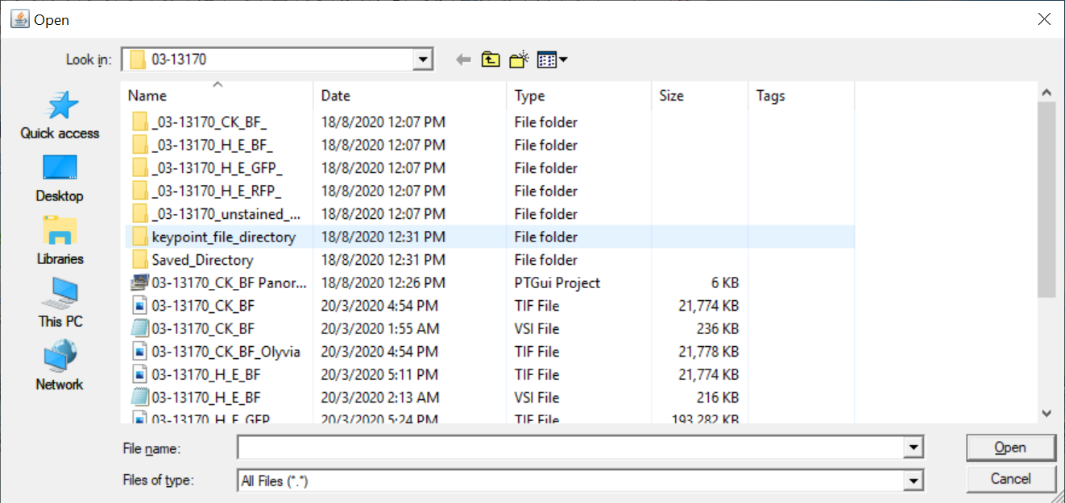

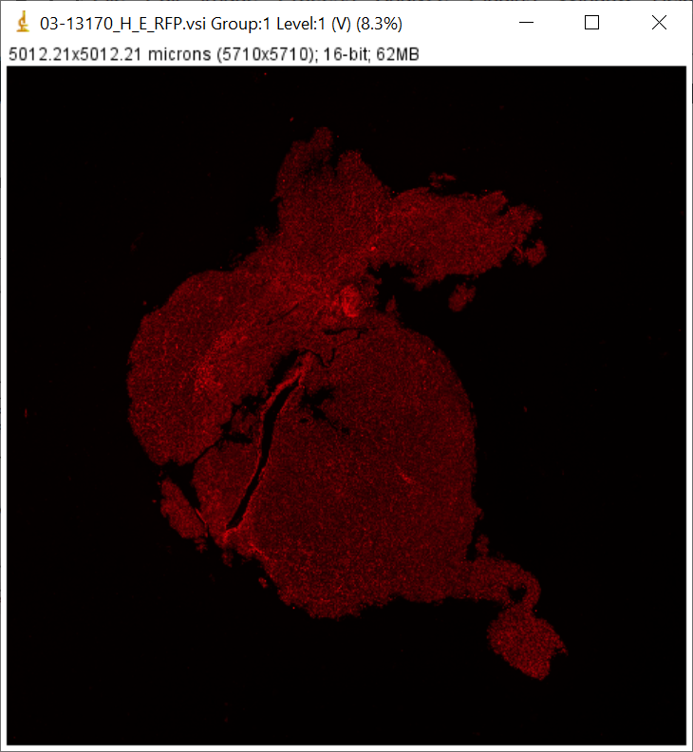

1. Originally the image is in 16 bit, when I try to change to RGB Color

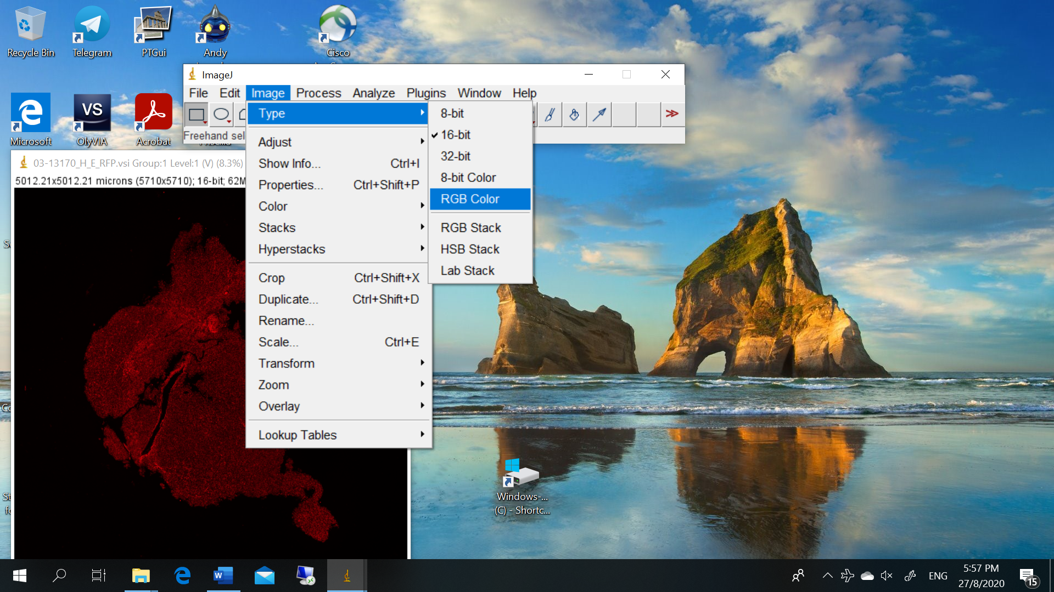

An error occur

Start :

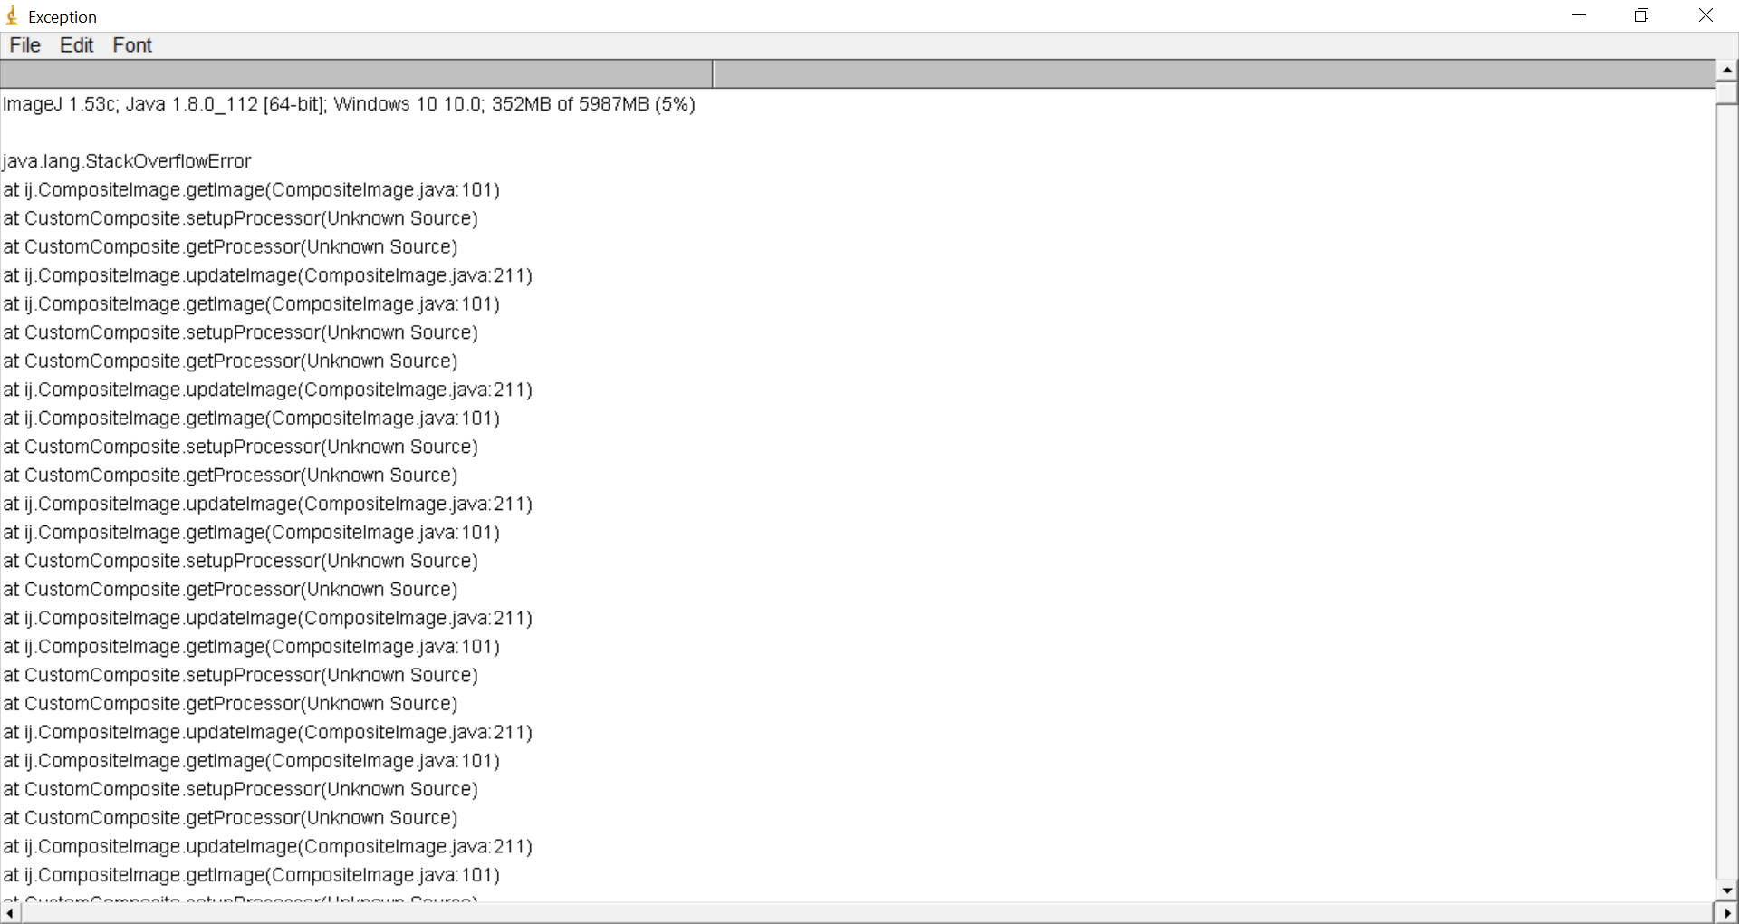

Ending:

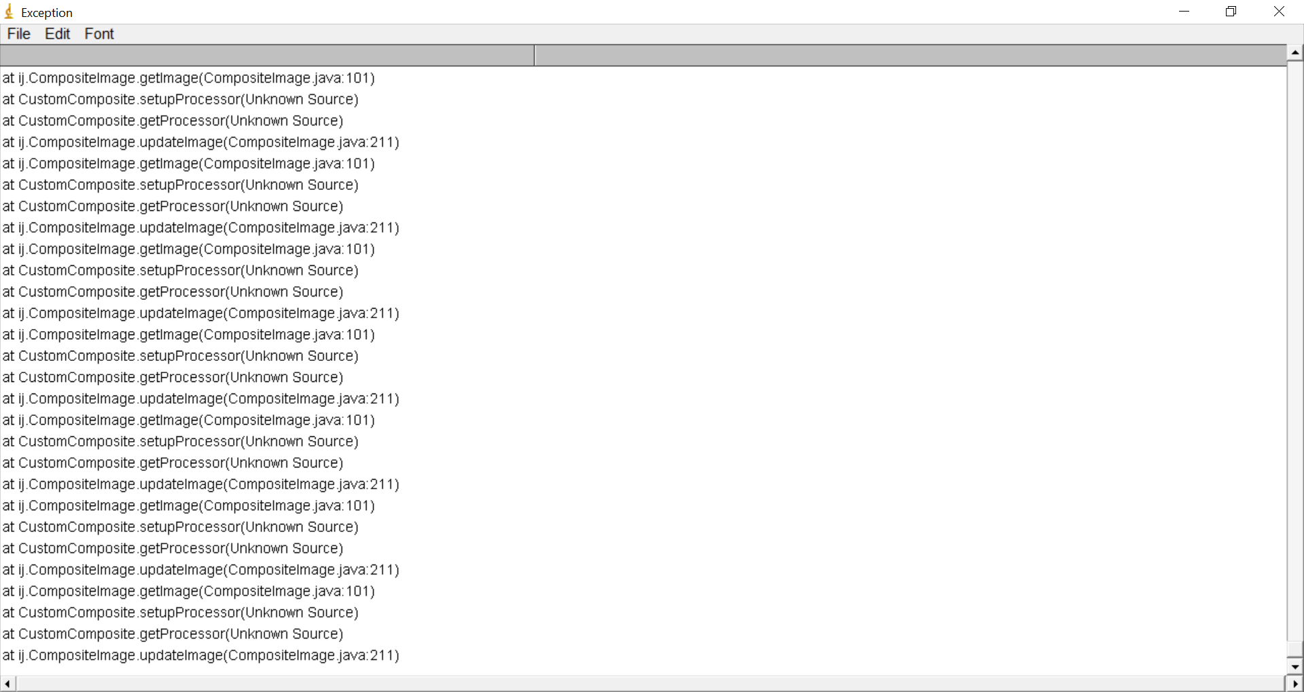

There is no problem with other server, but it really occurs on my Notebook ! So, may you give some help and advice on this ? Thanks !